Sample Newsletter Advert:

What if you could build a business from your passion?
- Dive into 5 days of FREE online training to take your idea from a thought to a reality.
- Learn about sales, marketing, social media, all of the legal stuff with a focus around making money not spending it.
- Join a community of like-minded people and the team that helped over 2000 people learn in 2020.
As the event is sponsored there no catch – no upsell. Check out the link below for all the details and to reserve your space:
To book: www.popupbusinessschool.co.uk/stratford
Enquiries: Liam Sibley, liam@popupbusinessschool.co.uk, 07841 589680 www.popupbusinessschool.co.uk

You might want to copy this jpg file for inclusion if you have space and attach the above booking link.
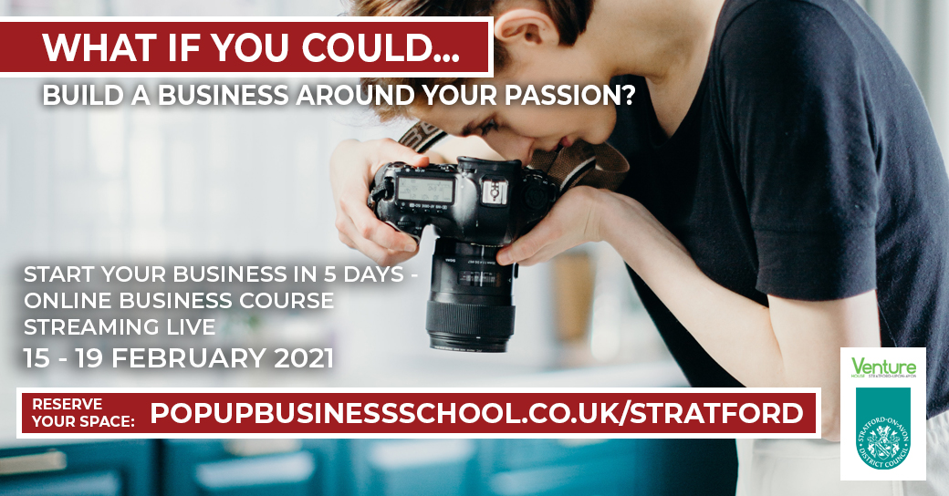

A bit more background if you need it:

What is the PopUp Business School?
We are the UK’s leading alternative to the traditional way of starting a business. ​Our FREE business courses show a new way of thinking and practical ways to get your business idea off the ground and how to sustain and thrive as a business. Whether you are at the beginning of your start-up journey, or you are an already established business, our course will give you the information, inspiration and practical advice to teach you how to build and evolve your business.

What do you mean free?
The course is free for you thanks to the support of Stratford District Council and Venture House. No one has EVER paid to attend a PopUp Business School anywhere in the world. NO Upselling. NO surprises. NO hidden terms and conditions. We promise.

Why should I attend?
If you want to take control of your life, in a full-time (but unsatisfying) job, if you’re unemployed and looking for the right path, been working on your own business for years or are already established and want to find out how to become adaptable, PopUp’s alternative method will help you to take action and make it happen.

